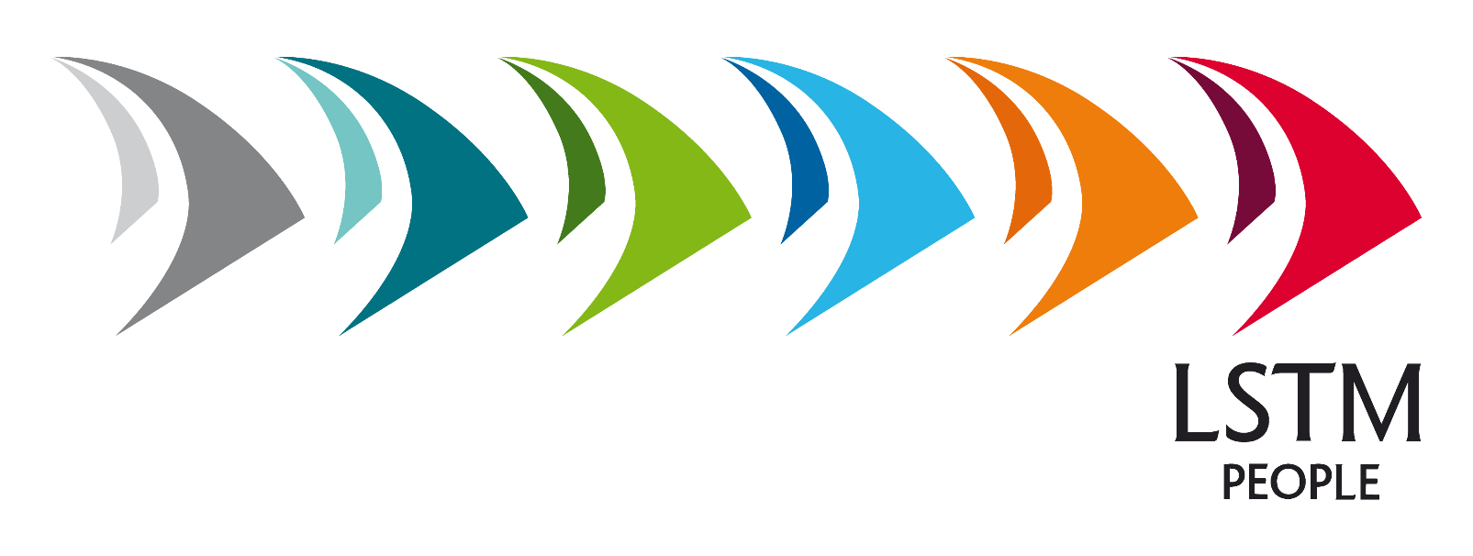

Equality, Diversity and Inclusion Report
2018-19

November 2019

Contents

Summary 3

1. Diversity and Inclusion Framework 4

2. Staff Equality Data – July 2019 11

Summary
NB: The statistics within this report were presented at Audit Committee earlier in the year.
2018-19 has been a year of change for the Human Resources team, especially within the Equality and Diversity provision. Our Equality and Diversity Officer has decided to move on from LSTM and a new post is currently being advertised. Following the appointment of a new Global Director of HR and a restructure of the HR team, the focus for LSTM’s Equality and Diversity (E&D) post has been widened. The new post is titled Inclusion, Diversity and Engagement Manager to reflect the new requirements. It sits within a newly formed OD and Engagement team, led by a Senior HR Manager (OD and Engagement) and currently including a Learning and Development Manager and HR Analyst, aimed at fostering a working environment that allows all to thrive.

The Equal Opportunities Committee has changed its name to the Equality and Diversity Committee and reviewed its membership, inviting representatives from the Women in Global Health group and a staff representative through the School Staff Forum. The aims of the committee have also been reviewed to ensure that the committee is focused on setting LSTM’s E&D strategy.

An Inclusion and Diversity Framework “Inclusivity as Standard” (see section 1 for text) has been created, approved by the E&D Committee and will be launched in the coming year. The document details the steps that the OD and Engagement team will take to stimulate further change at LSTM to achieve our aim of an organisational culture that welcomes all, respects and values differences and ensures that everyone can fully participate in employment, research and study. Future annual Equality and Diversity reports to the Board will refer to the progress made against this framework.

The reporting format for our people equality data (see section 2 ) has been reviewed to ensure it is user friendly, and staff data is now benchmarked against national HESA data to inform strategy and performance measures. Staff data in this format has also been forwarded for inclusion on LSTM’s website to comply with the Public Sector Equality Duty.

We continue to work on our Athena SWAN silver application, prioritising the areas of career progression and promotion opportunities, line manager development and support and flexible working. We will make our submission in 12 months’ time.

The OD and Engagement team continues to work on day to day equality issues, such as equality impact assessments on policies, working in partnership with policy writers to ensure that the needs of all are taken into account when setting out their approach.

2019-20 will be a year where the approach to inclusion and diversity will further change at LSTM, ensuring that all colleagues have the opportunity to take part, have their voice heard, and are aware that equality, diversity and inclusion are part of everyone’s core duties, responsibilities, actions and behaviours.

Diversity and Inclusion Framework

Inclusivity as Standard – LSTM Inclusion and Diversity Framework

Introduction

LSTM is an organisation with a global reach in employment, education and research. All our activities are delivered by and for a diverse population and LSTM is committed to ensuring that our practices are inclusive to all.

LSTM’s Management Team are committed to inclusion and diversity; developing an organisational culture which welcomes all, respects and values differences and ensures that everyone can fully participate in employment, research and study.

Our inclusion and diversity framework sets out our commitments to maintaining and improving our work and study environments, ensuring that everyone has the opportunity to develop with and use their unique perspectives to contribute to the success of LSTM.

Inclusive practices and behaviours are a day-to-day activity expected of everyone who comes into contact with LSTM. Supporting inclusivity and respecting differences are key in ensuring that LSTM can attract the best talent from around the world and create a culture where diverse points of view can come together and develop the most effective ways to meet our mission, vision and values.

This framework details the actions we will take to ensure that LSTM’s actions and culture support inclusion and diversity in the following areas:

- Governance
- People Management
- Culture and Environment
- Inclusion and Engagement

We will monitor and report on progress against our actions, ensuring transparency and accountability.

All LSTM colleagues, including myself, are expected to support this framework with their actions and behaviours. Inclusivity is standard at LSTM.

Professor David Lalloo MB BS MD FRCP FFTM RCPS (Glasg)
Director of LSTM and Professor of Tropical Medicine

- Governance

Regular review of our activities is critical to ensure that we are improving in valuing diversity and ensuring inclusion.

Aim: We will set targets to improve in diversity and inclusion, and hold ourselves to account for achievement through publication of reports and monitoring progress

  - Targets
We will:

    - Use data to set meaningful targets to improve diversity in the profile of staff at LSTM

    - Publish a gender pay action plan each year and report on our progress against the actions to Management Committee

    - Continue to work through our Athena Swan action plan

    - Take appropriate action to reduce complaints made regarding inappropriate behaviour linked to protected characteristics year-on-year

  - Reporting
We will:

    - Analyse equality data (as at 31st July) in August of each year, presenting to Audit Committee and Equal Opportunities Committee at their next planned meetings

    - Publish a UK-based staff overview on LSTM’s website by October of each year

    - Monitor diversity throughout the recruitment and selection process, report on and analyse conversion and drop-out rates and take action where potential issues are identified

    - Extend the suite of equality data to cover the employee experience from recruitment to exit (including development and progression)

    - Liaise with Education to provide an equivalent student experience report

    - Engage staff in annual monitoring process and promote increased participation

    - Provide optional returns to HESA for our staff

    - Conduct regular equal pay reviews and review the outcomes of our annual salary review processes to ensure fairness and consistency

    - Conduct pay gap reviews for protected characteristics, such as race and sexual orientation, publishing action plans where required

    - Report on complaints received via the Freedom to Speak Up campaign

  - Oversight
We will:

    - Ensure our Board of Trustees continues to include a Diversity and Inclusion Champion

    - Review our Equal Opportunities Committee, its membership, terms of reference and reports to Management Committee.

    - Continue to equality impact assess all proposed policies and procedures prior to implementation.

    - Continue to hold regular Equal Opportunities Committee meetings and self-assessment team meetings for external benchmark standard initiatives to ensure progress against our targets and acton plans.

- People Management

Our colleagues come from a wide range of backgrounds and people management processes and practices are a great opportunity to make them feel included in LSTM life and help them understand LSTM’s expectations about actions and behaviour.

  - Recruitment
Aim:
Ensure we are an Employer of Choice for a diverse global workforce, to improve diversity in our recruitment and appointment rates at all levels of the organisation

We will:

    - Develop our employer profile to ensure we reach talented candidates with diverse backgrounds for roles at all levels and in all areas.

    - Ensure all recruitment advertising and job descriptions are checked by our Recruitment and Selection team to ensure they are free from bias; inclusive language has been used, essential criteria are really needed to do the job from day one, and they promote a positive culture.

    - Provide recruitment and selection training, focusing on diversity and inclusion, for colleagues who have a role in the process.

    - Review and improve our blinding of recruitment processes and consider use of contextual recruitment tools where appropriate.

    - Review our employment offer pack and other onboarding materials to ensure they are free from bias, inclusive, and provide information that new starters need before their first day.

  - Development
Aim:
Improve retention and progression rates; to improve diversity in our academic, management and leadership positions

We will:

    - Have a specialist Learning and Development Manager to allow focus on providing opportunities for our colleagues to develop.

    - Review the career development information, opportunities and mechanisms available to all colleagues, regardless of specialism or background; establish mechanisms and support for flexible career paths (i.e., facilitate movement into alternative careers).

    - Seek to understand and overcome the barriers to career progression, reviewing promotion processes.

    - Introduce leadership and management development training as a means to support progression.

    - Develop a balanced succession plan.

    - Extend learning and development programmes so that they apply to all staff and everyone has a development plan.

    - Ensure all new starters complete an online equality and diversity training module as part of their probation period.

    - Ensure diversity and inclusion content is included in both the HR and Corporate induction sessions.

    - Hold specific induction sessions for colleagues who are joining LSTM from outside the UK, to ensure they are supported in settling into life in Liverpool.

  - Management
Aim:
We will be an employer of choice for a diverse workforce at all stages of the employee lifecycle.

We will:

    - Support managers to champion and promote inclusion and diversity within their teams as part of their remit

    - Review our current performance review system, asking colleagues for their views on how a new system should look

    - Enable and promote family friendly and flexible working opportunities to support all staff with caring responsibilities

    - Review the support we offer to staff who are returning from career breaks to maintain their career paths

    - Review our approach to occasional flexibility in start and end times of working days to support greater flexible working

- Culture and Environment

True inclusivity and diversity are supported by a culture where these are embedded and part of everyday organisational life and expectations.

  - Mainstreaming
We will:

    - Appoint an Inclusion and Engagement Officer to allow focus on improving diversity and fostering inclusion and engagement

    - Embed inclusion and diversity practices into the day to day life of the institution.

    - Look for ways to celebrate all of our diverse contributions to LSTM’s success

  - Dignity at Work
We will:

    - We will introduce a Dignity at Work policy, guidelines and awareness training to reinforce zero tolerance of bullying, harassment and discrimination in any guise at LSTM and support colleagues who make a complaint or are accused under the policy.

    - We will continue to investigate and monitor complaints received via the Freedom to Speak Up campaign.

  - Inclusive Practices
We will:

    - Investigate ways to say thank you to our colleagues when they have done something extraordinary, which would not normally be considered under the current salary review or promotion processes.

    - Review our contracts and policies to implement inclusive practices, including family friendly working.

    - Introduce cultural awareness training to support multi-cultural, global teams working together.

    - Ensure we include colleagues based outside Liverpool in all aspects of LSTM life including e.g., ensuring representation on LSTM committees.

    - Explore adoption of external benchmark standards as a means to deliver best practice, e.g.
- ECU Race Equality Charter
- Stonewall Diversity Champion Programme (UK & Global)
- Disability Confident Employer
- HR Excellence Framework

- Inclusion and Engagement

To widen debate and foster a thriving and inclusive community through engaging with colleagues, students, partners and other stakeholders.

  - Networks
We will:

    - Facilitate LSTM diversity champions to form and run staff-led networks, focusing on providing support and an opportunity for diverse groups to have their voice heard

  - Communication
We will:

    - We will develop an internal communications and engagement plan, including an employee survey focused on dignity and respect, as well as mechanisms to feedback

    - Foster a culture where colleagues are keen to participate in debate, report concerns and provide monitoring information free from worry about potential impact and cost to themselves

    - We will ensure that the imagery used in our publications accurately reflects the diversity of our LSTM community

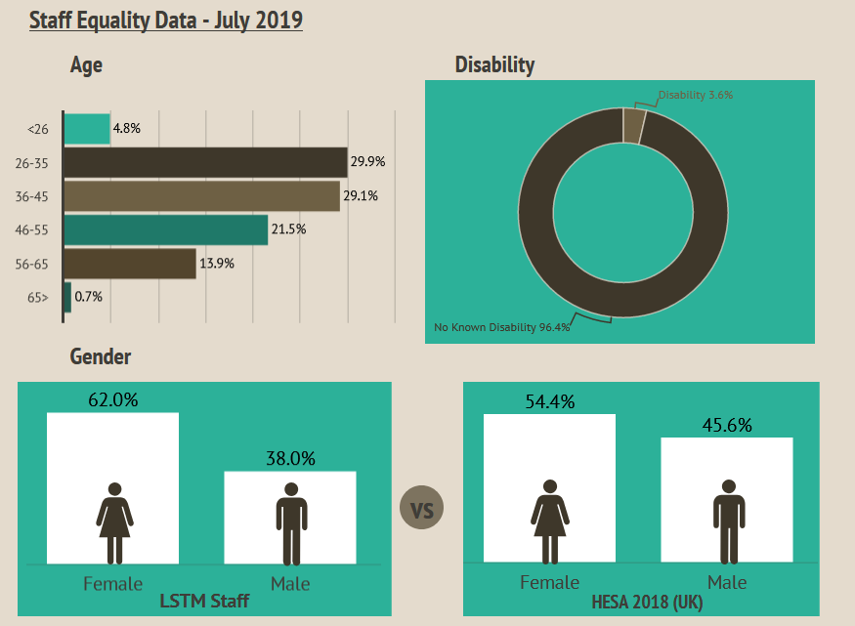
Staff Equality Data – July 2019
